Cybersecurity Risk Intelligence
A Multi-Layered Business Intelligence Analysis Using Power BI

Student’s Full Name: Mohammadali Ghaderi
Student’s Program: MSc in IT for Business Data Analytics
Module: Business Intelligence for Data-Driven Management
Academic Year / Semester: Autmn 2025
Word Count : 4349
Seminar leader: Reisch Ildikó
Due Date: 2025/12/15

Contents
Executive Summary 3
Introduction 4
The report first documents data lineage and modelling decisions, then analyses dashboard insights, and finally links findings to academic literature to derive business implications and strategic recommendations. 4
Data Lineage 5
Dataset Sources 5
Data Cleaning and Preparation 5
Data Modelling and Transformation in Power BI 6
Limitations and Potential Biases 7
Dashboard Analysis (Data Analysis Section) 7
Corporate Cyber Dashboard (Internal Risks) 7
Global Threats Dashboard (External Macro-Level Risk) 8
Global Risk Dynamics Dashboard (Cyber–Sustainability Link) 9
Global Maps Dashboard (Geopolitical Cyber Hotspots) 10
Cross-Dashboard Synthesis 11
Scientific Literature Review 12
Discussion: Alignment Between Data and Theory 12
Business Implications 13
Strategic Recommendations 14
Conclusion 15
References 16
Datasets 16
Books and Monographs (BI, dashboards, storytelling) 16
Cybersecurity and information security 16

Executive Summary
This report presents a business intelligence analysis of cybersecurity risk by integrating internal organizational data with global cyber threat trends and broader sustainability and governance indicators. Using three Kaggle datasets and Power BI dashboards, the analysis examines how cyber risks evolve at corporate, global, systemic, and geographic levels, and what these patterns mean for organizational decision-making.
At the organizational level, the analysis reveals a sharp increase in recorded cyber incidents over four years, rising from fewer than 50 to more than 1,000 cases. Human factors emerge as a key vulnerability: untrained employees account for more than half of all incidents, while phishing remains the most prevalent attack vector. Although high-risk assets are attacked less frequently, they generate disproportionately large financial losses, highlighting the need for risk-based prioritization rather than uniform security investment.
From a global perspective, cyber threats remain persistently high despite year-to-year fluctuations. Based on the global dataset ransomware is identified as the most financially damaging threat, responsible for over USD 28 billion in losses worldwide. Countries with large digital populations experience the greatest user exposure, suggesting that digital scale is a stronger driver of risk than technical preparedness alone. Incident resolution times also increase during peak threat periods, indicating operational capacity constraints across cybersecurity teams.
Systemic analysis shows that countries with stronger governance structures and higher renewable energy adoption tend to demonstrate greater cyber resilience. In contrast, rapid digital expansion without parallel governance development creates a “digital maturity gap” that increases exposure. Geographic patterns further confirm that cyber risk concentrates around major economic centers, while lower reported activity in emerging regions often reflects underreporting rather than lower risk.
Overall, the findings demonstrate that cybersecurity is a strategic challenge shaped by human behavior, digitalization, governance, and economic context. The report illustrates how business intelligence tools can transform complex cybersecurity data into actionable insights that support more resilient organizational strategies.

Introduction
Cybersecurity is now a strategic business challenge for modern organizations. As digital footprints expand through cloud adoption, automation, and increased connectivity, exposure to cyber threats rises accordingly. Incidents that once appeared as isolated technical problems increasingly create financial loss, operational disruption, and reputational harm, making organizational preparedness and recovery capability a core management concern.
Business intelligence (BI) provides a practical way to address this challenge by supporting data-driven analysis and decision-making (Milligan, 2020; So et al., 2018). In cybersecurity, where large volumes of heterogeneous data are generated, BI tools help convert incident records into actionable insight. Dashboards are particularly valuable because they translate complex datasets into clear, interactive views that can be understood by both technical teams and senior decision-makers (Knaflic, 2020).
This report examines cybersecurity risk from multiple perspectives by integrating three datasets: internal organizational incident data, global cyber threat data, and country-level sustainability and governance indicators. Using Power BI, these datasets are analyzed through four dashboards covering corporate risk exposure, global threat trends, systemic governance and digitalization dynamics, and geographic risk distribution.
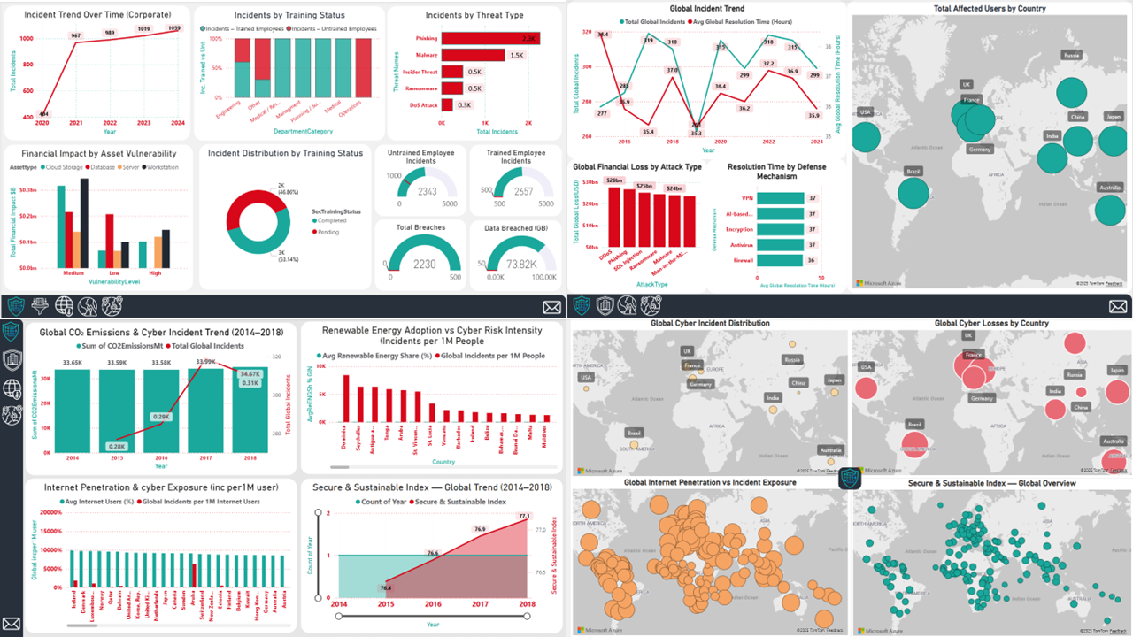
Figure 1 : Overview of the four Power BI dashboards used in this analysis (Author’s own, Power BI)

The report first documents data lineage and modelling decisions, then analyses dashboard insights, and finally links findings to academic literature to derive business implications and strategic recommendations.

Data Lineage
Establishing a clear data lineage is essential for ensuring analytical reliability, particularly in cybersecurity, where inaccurate or poorly documented data can lead to misleading conclusions. The datasets used in this project originate from different sources, vary in structure and granularity, and were created for distinct analytical purposes. As a result, transparent documentation of data sourcing, cleaning, and modelling was a foundational requirement to ensure that insights derived from the dashboards were trustworthy and reproducible.

Dataset Sources
This project integrates three openly available datasets from Kaggle, each contributing a distinct analytical perspective:
- Corporate Cyber Incidents Dataset (Kaggle, 2024)
Provides an internal organizational view, including incident types, financial losses, asset vulnerability levels, employee training status, and response metrics. This dataset supports analysis of human factors, operational behavior, and asset-level risk.
- Global Cybersecurity Threats Dataset (2015–2024) (Kaggle, 2024)
Captures worldwide cyber incident trends over a ten-year period, including threat categories, economic impact, user exposure, and resolution times. Its longitudinal structure enables cross-country comparison and global contextualization of internal findings.
- World Sustainability and Governance Indicators Dataset (Kaggle, 2024)
Adds systemic context through indicators such as renewable energy adoption, internet penetration, and governance quality. These variables support exploration of how national-level institutional maturity relates to cyber resilience.
Together, these datasets enable a multi-layered analysis spanning organizational, global, and systemic dimensions of cyber risk.

Data Cleaning and Preparation
The datasets differed significantly in naming conventions, formats, and completeness. Data cleaning was therefore conducted through several iterative steps to ensure consistency and analytical integrity, following established BI and data storytelling practices (Knaflic, 2020; Kriebel & Murray, 2018).
Key preparation steps included handling missing values in critical identifiers, standardizing country names to enable reliable joins, and creating a unified Year dimension to align time-series analysis across datasets. Categorical fields such as threat types, vulnerability levels, and training status were normalized to remove semantic duplication (e.g., grouping variations of phishing-related labels). Duplicate records and irrelevant metadata were removed to improve model efficiency and clarity.
These steps ensured that the data was coherent, comparable, and suitable for cross-dashboard analysis.
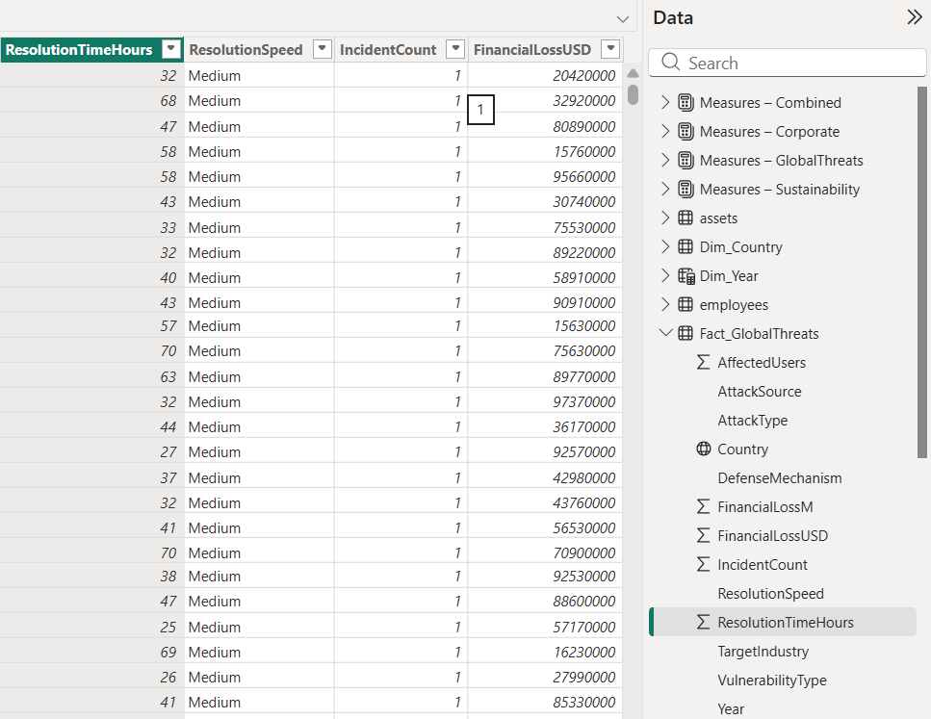
Figure 2: Example of data cleaning and transformation steps applied in Power BI Power Query (Author’s own, Power BI)

Data Modelling and Transformation in Power BI
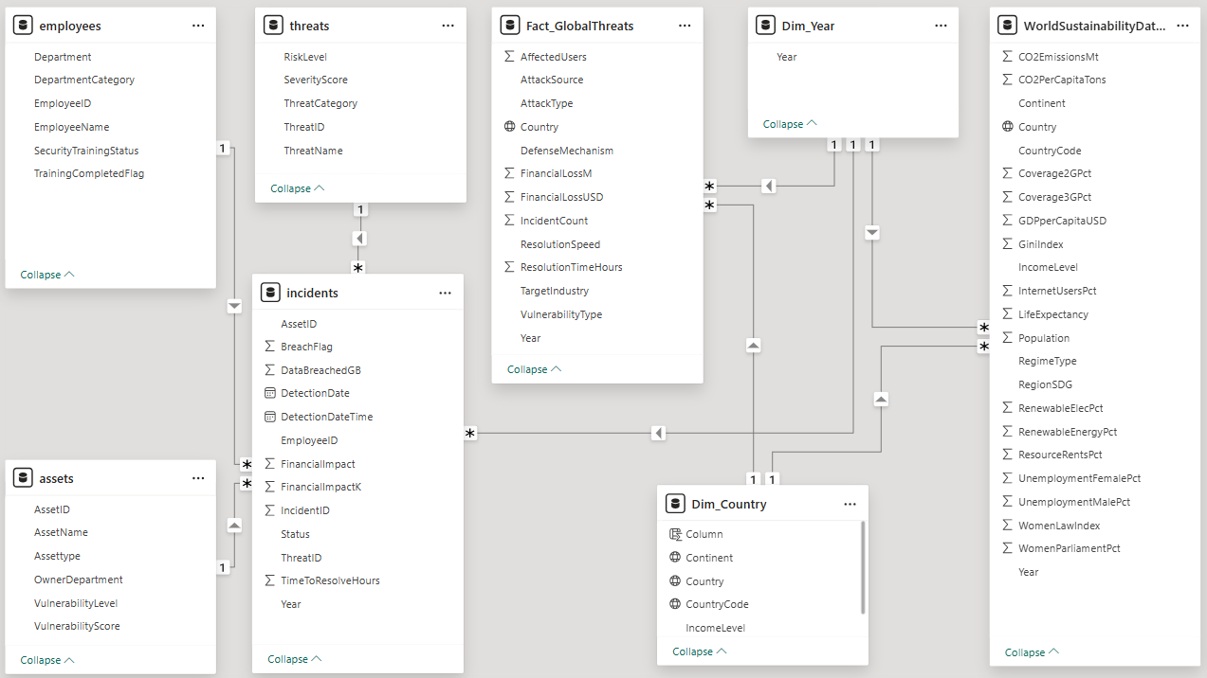
Figure3: Power BI data model showing relationships by Country and Year (Author’s own, Power BI)
Following data preparation, a unified data model was constructed in Power BI. A star-schema structure was adopted, with incident records acting as fact tables and countries, years, threat categories, and training status serving as dimension tables. This design reduced redundancy, improved performance, and enabled flexible filtering.
Relationships between datasets were primarily established using Country and Year keys, allowing synchronized filtering across dashboards. Custom DAX measures, such as incident growth rate, loss per incident, incidents per million residents, and governance-related indicators were created to support analytical depth beyond raw values. Hierarchies for time (Year → Quarter → Month) and geography (Country → Region) enabled intuitive drill-down and exploration.

Limitations and Potential Biases
No dataset is complete, and cybersecurity data is particularly affected by reporting and visibility gaps. Incident levels may be understated in regions with weaker monitoring and disclosure, so low counts do not necessarily indicate low risk. In addition, reporting definitions and thresholds vary across countries, which reduces the precision of cross-country comparisons. Finally, the sustainability and governance indicators used here provide contextual signals rather than direct measures of cybersecurity maturity, so observed relationships should be interpreted as indicative rather than causal. Despite these constraints, the cleaned and integrated model remains suitable for comparative analysis and decision-oriented insight.

Dashboard Analysis (Data Analysis Section)

Corporate Cyber Dashboard (Internal Risks)
The Corporate Cyber Dashboard provides a focused view of the organization’s internal cybersecurity posture between 2020 and 2024. Unlike global datasets, this dashboard reflects internal operational dynamics, illustrating how human behavior, asset vulnerability, and organizational processes interact to shape cyber risk.
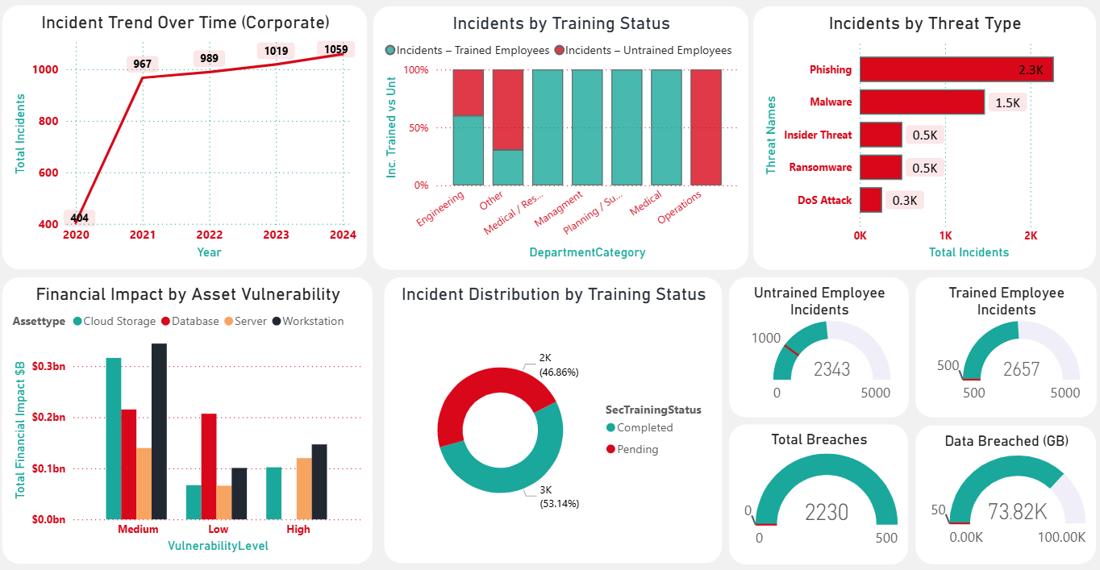
Figure 4: Corporate cyber dashboard: incidents, human factors, asset risk. (Author’s own, Power BI)
A key insight is the sharp rise in recorded incidents, increasing from 40 in 2020 to 1,059 in 2024. This trend reflects a combination of expanding digital infrastructure, increased attack activity, and improved detection capabilities, a pattern commonly observed as monitoring systems mature (ENISA, 2024).
Human behavior emerges as the most significant internal risk factor, with untrained employees involved in 53% of incidents. This finding aligns with the socio-technical view of cybersecurity, which emphasizes that user behavior and organizational culture play a central role in shaping risk (Von Solms & Van Niekerk, 2013). It suggests that targeted, role-specific training could substantially reduce incident frequency.
Threat analysis further reinforces this conclusion. Phishing dominates the internal threat landscape by a wide margin, reflecting its effectiveness and scalability as an attack method (ENISA, 2024). This highlights the continued importance of combining technical email controls with sustained user awareness initiatives.
From a strategic perspective, the dashboard shows that high-value, high-vulnerability assets account for a disproportionate share of financial losses, despite not being the most frequently attacked. This supports a risk-based security approach, where protection efforts are prioritized according to potential impact rather than incident volume alone.
Finally, operational indicators suggest growing pressure on internal response capabilities. While detection has improved, elevated breach counts, and exposed records indicate that response processes may not have scaled at the same pace as incident growth.
Overall, the Corporate Cyber Dashboard reveals an internal risk profile driven by human behavior, phishing-dominated threats, and concentrated asset vulnerability. These findings provide a clear baseline for comparison with global and systemic risk patterns in the following sections.

Global Threats Dashboard (External Macro-Level Risk)
The Global Threats Dashboard provides an external benchmark for evaluating the organization’s internal cybersecurity experience. By examining global incident trends, financial losses, user impact, and response performance over nearly a decade, it shows that internal challenges reflect a broader and persistent global risk environment.
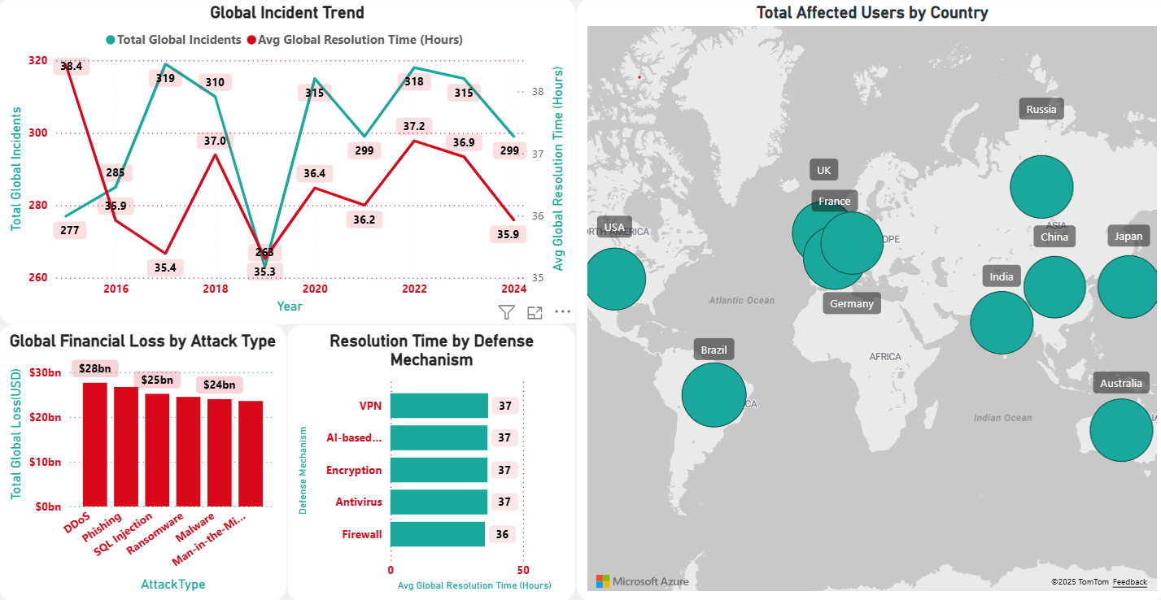
Figure 5: Global threats dashboard: incidents, losses, exposure (Author’s own, Power BI)
A central pattern in the global data is sustained incident volatility, with year-to-year fluctuations of approximately ±15%. Despite this variation, overall incident levels remain consistently high, indicating that cyber threats have become a structural feature of the global digital ecosystem rather than temporary disruptions (ENISA, 2024).
The dashboard also reveals a clear link between incident volume and response performance. During high-incident periods, average resolution times increase, suggesting that cybersecurity response capacity struggles to scale with rising attack volumes (ENISA, 2024; IBM Security, 2024). This pattern mirrors internal findings and points to a systemic operational challenge.
Financial impact further reinforces global risk severity. Ransomware emerges as the most economically damaging threat, accounting for more than USD 28 billion in global losses (IBM Security, 2024). Its combined impact on system availability and data confidentiality highlights the importance of strong recovery and containment capabilities.
A further insight is the digital density effect. Countries with large internet-using populations, such as the United States, China, and India, experience disproportionately high user impact. This suggests that digital scale, rather than defensive maturity alone, is a key driver of exposure, as expanding connectivity increases the attack surface.
Overall, the Global Threats Dashboard contextualizes the organization’s internal experience within global patterns, confirming that dominant threats, response pressures, and financial impacts align closely with worldwide trends. This enables more effective benchmarking and informed risk anticipation.

Global Risk Dynamics Dashboard (Cyber–Sustainability Link)
While the corporate and global threat dashboards focus on direct cybersecurity outcomes, the Global Risk Dynamics Dashboard examines the broader conditions under which cyber risk develops. It explores how digitalization, governance maturity, and sustainability-related indicators interact to shape national cyber resilience.
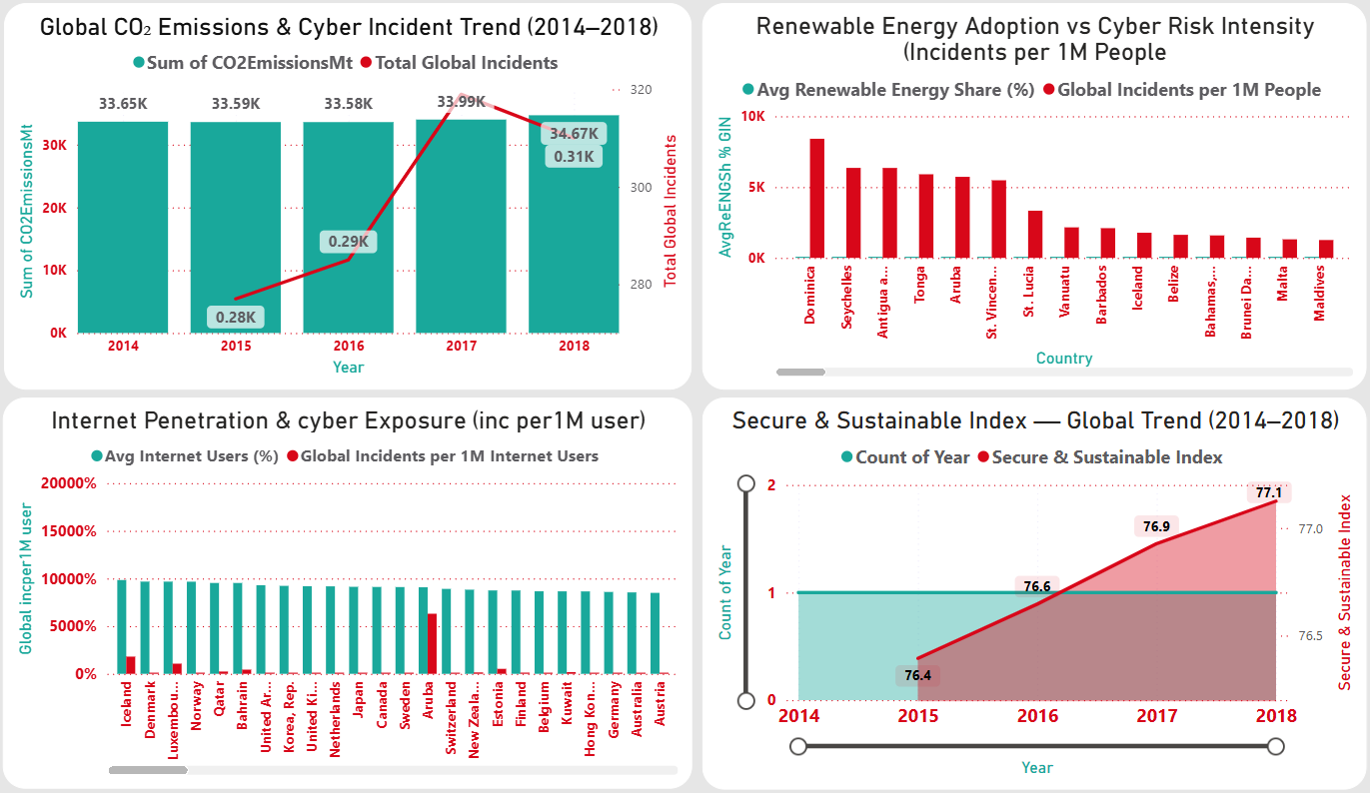
Figure 6: Global risk dynamics dashboard: incidents, digitalization, sustainability (Author’s own, Power BI)
A key pattern is that cyber incidents continue to rise even as CO₂ emissions stabilize or decline. This does not imply a direct environmental cause but reflects a structural dynamic: many countries are expanding digital infrastructure faster than cybersecurity frameworks and governance mechanisms evolve. As reliance on interconnected systems increases, so does exposure to cyber risk.
The dashboard also shows that countries with higher renewable energy adoption, often those with stronger governance and regulatory capacity, tend to experience fewer cyber incidents per capita. This suggests that sustainability indicators may act as proxies for institutional maturity and long-term planning rather than direct protective factors.
Internet penetration emerges as another strong driver of exposure. Nations with widespread connectivity consistently face higher incident levels, reinforcing earlier findings that digital density is a key predictor of cyber risk. As digital participation expands, the potential impact of disruption increases accordingly.
A particularly concerning insight is the presence of a digital maturity gap. In many countries, digital adoption outpaces the development of governance and regulatory capacity, leading to higher incident rates and weaker response performance (ENISA, 2024). Where governance lags connectivity, cyber risk escalates rapidly.
Overall, the Global Risk Dynamics Dashboard demonstrates that cyber risk is shaped by systemic factors beyond technology alone. Countries that align digital growth with strong governance and sustainability strategies tend to manage cyber risk more effectively, while those that neglect institutional development face heightened exposure.

Global Maps Dashboard (Geopolitical Cyber Hotspots)
The Global Maps Dashboard adds a spatial perspective to the analysis, illustrating how cyber risk is unevenly distributed across regions and shaped by economic scale, digital penetration, and governance quality. Unlike trend-based views, the geographic map makes risk concentration immediately visible.
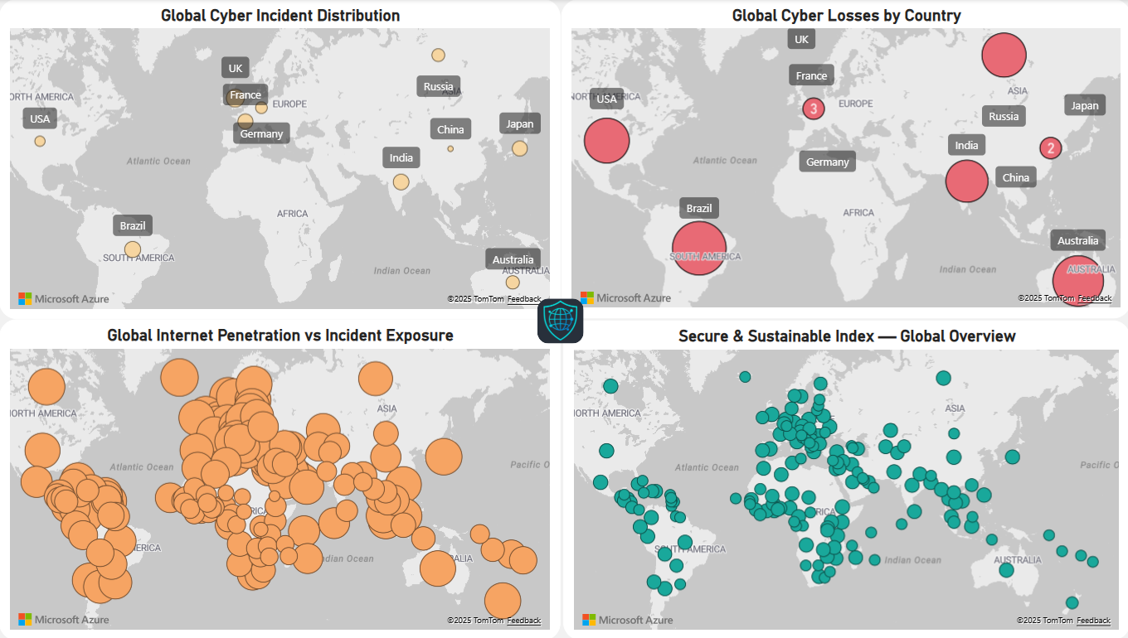
Figure 7: Global map of cyber incidents and impact (Author’s own, Power BI)
A clear pattern is the clustering of cyber activity around major digital economies. Countries such as the United States, China, and India collectively account for approximately 40–50% of global incidents, financial losses, and user exposure (ENISA, 2024). This reflects the strategic targeting of highly connected, high-value digital ecosystems.
The map also shows that low reported incident levels do not necessarily indicate low risk. Several regions in Africa and parts of South America display fewer recorded incidents, a pattern more closely associated with limited digital penetration, weaker monitoring capacity, and underreporting than genuine safety (IBM Security, 2024). Organizations operating in these regions may therefore face hidden or poorly documented risks.
Economic value further influences geographic exposure. Countries with higher GDP tend to experience greater financial losses per incident, particularly where digital infrastructure and global supply chain integration are dense. In contrast, countries with strong governance and sustainability indicators often show lower adjusted incident rates when normalized by population and digital footprint, suggesting that institutional maturity contributes to cyber resilience.
Overall, the Global Maps Dashboard demonstrates that cyber risk is geographically uneven and closely tied to economic influence, digital behavior, and governance strength. This spatial insight supports the need for region-specific cybersecurity strategies and differentiated risk management across global operations.

Cross-Dashboard Synthesis
When considered together, the four dashboards: corporate, global, systemic, and geographic present a coherent picture of cybersecurity risk. Although each dashboard focuses on a different analytical layer, their combined insights reveal consistent structural patterns that extend beyond individual incidents or regions. Overall, the synthesis shows that cyber risk is shaped by the interaction of human behavior, digital scale, economic value, and governance maturity.
A dominant finding across all dashboards is the role of human behavior. Internally, a large share of incidents involves untrained employees, while phishing remains the most common attack vector both within the organization and globally. Despite technological progress, social engineering continues to be highly effective, supporting the view that cybersecurity is fundamentally a socio-technical challenge rather than a purely technical one.
Another recurring pattern is the influence of digital scale on exposure. Globally, countries with large digital populations experience higher user impact, a trend clearly reflected in the geographic dashboards. Internally, incident growth mirrors the organization’s expanding digital footprint. These patterns indicate that digital density has become a stronger predictor of exposure than defensive maturity alone, as larger and more interconnected environments inherently present broader attack surfaces.
Governance and institutional maturity emerge as important moderating factors. Countries with stronger governance and sustainability indicators tend to show lower incident rates per capita, while weaker institutional frameworks amplify risk. This is echoed internally, where effective response depends on SOC capacity, internal controls, and policy enforcement. In both contexts, governance plays a stabilizing role by limiting the impact of growing digital exposure.
The dashboards also consistently show that cyber risk concentrates around high-value targets. Critical organizational assets generate disproportionate financial losses, while globally, economically significant countries experience the greatest impact. This reinforces the importance of prioritizing protection based on potential impact rather than incident frequency alone.
Overall, the synthesis highlights a shared structural challenge: digitalization is often advancing faster than preparedness and governance. By integrating insights across dashboards, the analysis moves beyond isolated findings and provides a clear foundation for translating data-driven insights into strategic business decisions.

Scientific Literature Review
Academic literature on cybersecurity and business intelligence provides important context for interpreting the dashboard findings. While the dashboards illustrate observable patterns in incidents, threats, and impacts, prior research helps explain why these patterns emerge and how organizations can respond more effectively.
Business intelligence literature emphasizes that data only becomes valuable when it supports informed decision-making. Milligan (2020) highlights the importance of robust data modelling and interactive dashboards that allow users to explore patterns across time and geography. This principle underpins the analytical design of this project, where structured modelling and calculated measures enable meaningful comparison of cyber risks across organizational, global, and systemic dimensions.
Research on data visualization further argues that effective dashboards should prioritize clarity over volume. Knaflic (2020) stresses that decluttered visuals and clear emphasis help decision-makers focus on what matters most, while Kriebel and Murray (2018) advocate iterative refinement to improve interpretability. These principles support the dashboard design choices in this project, where unnecessary visual complexity was reduced to strengthen analytical insight rather than descriptive reporting.
Cybersecurity literature strongly supports the project’s core findings. Von Solms and Van Niekerk (2013) describe cybersecurity as a socio-technical challenge in which human behavior and organizational culture play a central role. This aligns directly with the internal dashboard results, where untrained employees account for a substantial share of incidents and phishing dominates threat types. Industry reports reinforce this view: ENISA (2024) and IBM Security (2024) consistently identify phishing and ransomware as persistent drivers of cyber harm and note that rising attack volumes place increasing pressure on response capabilities.
Recent research also treats cyber risk as systemic rather than purely technical. Studies linking digitalization with governance maturity suggest that institutional capacity and regulatory quality influence how effectively cyber risks are managed. This perspective helps explain the dashboard evidence showing lower incident rates per capita in countries with stronger governance indicators and supports the integration of internal incident data with global and contextual datasets.
Overall, the literature reinforces the analytical approach adopted in this project. It confirms that effective cybersecurity depends not only on technical controls, but also on data-driven decision-making, organizational preparedness, and governance structures capable of managing risk in complex digital environments.

Discussion: Alignment Between Data and Theory
The dashboard findings align closely with established theories in cybersecurity and business intelligence, reinforcing the validity of the analysis. Rather than presenting isolated results, the data reflects broader structural and behavioral patterns widely documented in academic and industry literature, indicating that the observed risks are systemic rather than organization specific.
A key point of alignment concerns human behavior. Internally, a large share of incidents is linked to untrained employees, with phishing as the dominant attack vector. This supports the socio-technical perspective proposed by Von Solms and Van Niekerk (2013), which emphasizes that cybersecurity effectiveness depends not only on technical controls but also on user behavior and organizational culture. The findings confirm that technological safeguards alone cannot fully mitigate risk when awareness remains limited.
Another strong alignment relates to digital expansion and exposure. Both internal and global dashboards show that incident volumes increase as digital environments grow. Highly connected countries experience greater threat activity, while the organization’s own incident levels rose alongside its expanding digital footprint. This reflects the widely recognized “expanding attack surface” problem, where digitalization progresses faster than defensive capacity (ENISA, 2024; IBM Security, 2024).
The Global Risk Dynamics Dashboard further supports governance-focused research. Countries with stronger governance and sustainability indicators tend to show lower incident rates per capita, while rapid digitalization without institutional maturity leads to elevated risk. This mirrors policy literature highlighting the importance of regulatory capacity and governance readiness in managing digital threats.
From a business intelligence perspective, the project’s modelling and dashboard design follow established best practices that prioritize clarity, interpretability, and narrative focus (Knaflic, 2020; Kriebel & Murray, 2018; Milligan, 2020). These choices enabled complex cybersecurity data to be translated into insights accessible to non-technical decision-makers.
Overall, the findings reinforce existing theory rather than contradict it. The literature explains the structural drivers observed in the data, while the dashboards provide practical evidence of these dynamics, strengthening confidence in the analysis and supporting the business implications and recommendations that follow.

Business Implications
The dashboard findings show that cybersecurity must be managed as a business-wide issue rather than a purely technical function. Incident growth, threat patterns, financial losses, and response performance all indicate that cyber risk is shaped by everyday behavior, strategic priorities, and organizational readiness—many of which are influenced by decisions made outside IT.
A key implication is the central role of human behavior. Untrained employees are linked to a large share of incidents, while phishing remains the most common attack vector across internal and global data. This confirms that cybersecurity effectiveness depends heavily on organizational culture and user awareness. For management, this means responsibility for cybersecurity must extend beyond specialist teams and be reinforced through regular training, leadership involvement, and clear behavioral expectations.
The dashboards also highlight the importance of risk-based resource allocation. Financial losses are concentrated in a small number of high-value or high-vulnerability assets, even when those assets are not the most frequently targeted. Rather than spreading resources evenly, organizations should prioritize protection based on business impact, focusing on systems whose compromise would cause the greatest harm.
Operational resilience presents another critical implication. Both internal and global data show that response effectiveness declines during high-incident periods, indicating that security teams can become strained under pressure. This demonstrates that resilience depends not only on prevention but also on the ability to detect and respond quickly. Delayed containment increases downtime, costs, and reputational damage, making response readiness a strategic concern for senior management.
Finally, regional analysis shows that cyber risk varies significantly across markets. Highly digitalized economies face elevated exposure, while low-reporting regions may hide underlying vulnerabilities due to limited monitoring. For organizations operating internationally, cybersecurity considerations should therefore be integrated into expansion, outsourcing, and partnership decisions alongside traditional economic factors.
Overall, the dashboards demonstrate that cybersecurity is inseparable from organizational strategy. Businesses that treat cyber risk as a shared responsibility, prioritize critical assets, and strengthen response capacity are better positioned to reduce losses and sustain trust in an increasingly complex digital environment.

Strategic Recommendations
The analysis highlights a set of priority actions that can significantly improve organizational cybersecurity resilience. Rather than attempting to address every threat equally, these recommendations focus on the core drivers of risk identified in the dashboards and supported by the literature.
A first and essential recommendation is to strengthen human-centric cybersecurity practices. Internal data shows that untrained employees are linked to a majority of incidents, while phishing remains the most prevalent attack vector both internally and globally. Organizations should therefore treat cybersecurity awareness as an ongoing organizational process rather than a one-off compliance exercise. Regular, role-appropriate training and clear reporting channels for suspicious activity can substantially reduce incident frequency and relieve pressure on security teams. Leadership involvement is critical to reinforcing cybersecurity as a shared responsibility across the organization.
Second, organizations should adopt a risk-based approach to protecting digital assets. The dashboards demonstrate that a small number of high-value, high-vulnerability systems account for a disproportionate share of financial losses. Security investment should therefore be prioritized according to potential impact rather than incident frequency alone. By concentrating controls around critical systems and sensitive data, organizations can reduce the severity of breaches even when incidents occur.
A third recommendation concerns operational readiness and incident response capacity. Both internal and global analyses show that response effectiveness declines during periods of high incident volume. This indicates that many organizations operate close to their response limits. Improving incident response processes, clarifying escalation pathways, and reducing manual workload can help organizations contain threats more quickly, limiting downtime and financial damage.
Finally, organizations should integrate cybersecurity more closely with broader strategic and governance considerations. The dashboards reveal that cyber risk is influenced by digital scale, governance maturity, and regional context. For organizations operating internationally, this means that cybersecurity considerations should be embedded into decisions around market expansion, partnerships, and long-term digital transformation. Using data-driven insights to monitor evolving risk conditions enables organizations to move from reactive defense toward proactive risk management.
Taken together, these recommendations emphasize focus over breadth. By prioritizing people, protecting what matters most, strengthening response capability, and aligning cybersecurity with strategic decision-making, organizations can significantly improve resilience in an increasingly complex digital environment.

Conclusion
This project demonstrates that cybersecurity is not merely a technical issue but a strategic and organizational challenge that evolves alongside digitalization. By integrating internal incident data with global threat trends, sustainability indicators, and geographic analysis, the dashboards reveal a consistent pattern: cyber risk increases when digital systems expand faster than human preparedness, governance structures, and defensive capacity.
At the organizational level, the rise in incidents and the prominent role of untrained employees highlight the importance of human behavior in shaping cybersecurity outcomes. Globally, the dominance of phishing and ransomware, together with increasing resolution times, reflects growing pressure on cybersecurity capabilities and the escalating sophistication of threat actors. At a systemic level, the relationship between governance quality, sustainability maturity, and cyber resilience shows that institutional strength plays a critical role in managing digital risk. The geographic analysis further demonstrates that cyber risk is unevenly distributed, clustering around highly connected and economically significant regions, while underreported areas may conceal hidden vulnerabilities.
The academic literature reviewed supports these findings, emphasizing the importance of people, governance, and institutional maturity in effective cybersecurity management. Business intelligence tools provide a crucial link between complex data and strategic decision-making, enabling organizations to move beyond reactive responses toward proactive risk management.
Overall, the analysis reinforces a central insight: cybersecurity is a shared organizational responsibility that extends beyond IT functions. Organizations that align cybersecurity with strategy, governance, and data-driven decision-making are better positioned to manage risk, protect critical assets, and maintain trust in an increasingly complex digital environment.

References

Datasets
Corporate Cyber Incidents Dataset. Available at: https://www.kaggle.com/datasets/alperenmyung/corporate-cyber-security-analytics (Accessed: 17 November 2025).
Global Cybersecurity Threats Dataset (2015–2024). Available at: https://www.kaggle.com/datasets/atharvasoundankar/global-cybersecurity-threats-2015-2024 (Accessed: 17 November 2025).
World Sustainability and Governance Indicators Dataset. Available at: https://www.kaggle.com/datasets/truecue/worldsustainabilitydataset (Accessed: 17 November 2025).

Books and Monographs (BI, dashboards, storytelling)
Dykes, B., 2020. Effective Data Storytelling: How to Drive Change with Data, Narrative and Visuals. Hoboken: Wiley.
Knaflic, C.N., 2020. Storytelling with Data: Let’s Practice. Hoboken: Wiley.
Kriebel, A. and Murray, E., 2018. #MakeoverMonday: Improving How We Visualize and Analyze Data, One Chart at a Time. Hoboken: Wiley.
Milligan, J., 2020. Learning Tableau 2020: Create Effective Data Visualizations, Build Interactive Visual Analytics, and Transform Your Organization’s Data into Actionable Insight. 3rd ed. Birmingham: Packt Publishing.
So, B., Fritz, M. and Perisic, M., 2018. Mastering Microsoft Power BI. Birmingham: Packt Publishing.
Wexler, S., Shaffer, J. and Cotgreave, A., 2017. The Big Book of Dashboards: Visualizing Your Data Using Real-World Business Scenarios. Hoboken: John Wiley & Sons.

Cybersecurity and information security
IBM Security, 2024. Cost of a Data Breach Report 2024. IBM Corporation. Available at: https://www.ibm.com\ (Accessed: 21 November 2025).
ENISA, 2024. ENISA Threat Landscape 2024. European Union Agency for Cybersecurity. Available at: https://www.enisa.europa.eu/topics/cyber-threats/threat-landscape\ (Accessed: 23 November 2025).
Von Solms, R. and Van Niekerk, J., 2013. Cybersecurity and information security, what goes where? Information & Computer Security, 21(5), pp.345–356.
Use of AI Tools
Artificial intelligence tools were used in a limited and supportive manner during the preparation of this report. ChatGPT (OpenAI) was used primarily for summarization of background materials, language refinement, clarification of concepts, and improving the structure and readability of the written text. No AI tools were used to generate the data analysis, create results, or produce the business insights and conclusions. All data sourcing, data preprocessing, data analysis, dashboard development, interpretation of results, and business conclusions were conducted by the author, who takes full responsibility for the content of this report.

Excluding the cover page, table of contents, references and appendices.

